Goal: Train an image classifier to classify images between dogs and cats
Technologies used: PyTorch, ResNet18, transfer learning, and Streamlit deployment
What are we basically doing in the code?
We are classifying images to determine if they are cat images or dog images. There are 2 categories: Cats and Dogs.
We are going to use:
- PyTorch for model training
- ResNet18 for transfer learning
- Kaggle Cats vs Dogs dataset
- Streamlit for deployment
Output is a simple webapp where the user can upload images and get prediction along with confidence scores.
What is Transfer Learning?
Training a deep neural network from scratch is expensive and elaborate. Instead we use transfer learning, which is a machine learning technique in which the knowledge gained from one model is used to improve model performance of a different or related model or dataset. Here we freeze most of the network and only use the final layer for classification and specialisation, making it effective.
What is ResNet 18 model?
Initially the researchers were stacking up layers to improve performance of models in deep neural networks. However they realised after a certain number of layers, the performance decreases. However this degradation is not because of overfitting but by optimization difficulties.
ResNet introduced the idea of Residual connections.
The key innovation is that instead of learning a mapping H(x), each residual block learns F(x) = H(x) - x, where the final output is F(x) + x. This means the block only needs to learn the residual or "correction" to add to the input.
This solves two problems:
- Vanishing gradients: In deep networks, gradients need to flow backwards during backpropagation many times. Every time these gradients get multiplied or averaged and essentially becomes close to 0 and the early layers stops learning something. However with ResNet the gradients can flow through skip connections without being diminished by layer operations.
- Degradation Problem: Plain deep networks struggle with identity mappings.
Considering a simple layer: y = σ(Wx + b), where σ is a nonlinearity like ReLU.

To learn the identity mapping y = x, we need:
W to be the identity matrix
b to be zero
The nonlinearity to not interfere
This is a problem because?
Random initialization starts W and b at random values. ReLU and other nonlinearities distort the signal. Multiple consecutive layers compound the problem.
With residual blocks, the output is: y = F(x) + x
where F(x) = σ(W₂σ(W₁x + b₁) + b₂)
An identity mapping is simply a function that outputs exactly what it receives as input. In mathematical notation: f(x) = x. Due to having many layers, sometimes it is just easy to pass data as it is, especially when the number of layers is more than necessary.
To achieve identity (y = x), we now just need F(x) = 0.
This means:
Initialize weights near zero (or let them decay to zero).The network learns "corrections" or "refinements" to the input.
The mathematical advantage:
During backpropagation, we consider the gradient:
Plain network: ∂y/∂x = ∂F/∂x (can vanish or explode)
Residual network: ∂y/∂x = ∂F/∂x + 1 (always has the "+1" term)
The "+1" ensures gradients flow backward even if ∂F/∂x is tiny.
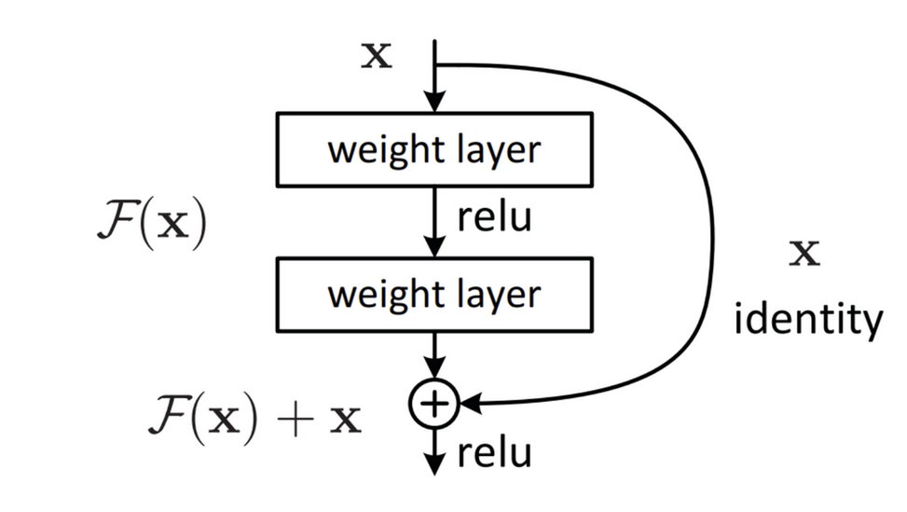
ResNet is the goto model for classification of images because of how lightweight it is.

Data Preparation and Augmentation

ResNet does not understand images, so we need to do data preprocessing. It learns to map pixel patterns to labels by adjusting millions of weights to minimise prediction error. So for a cat photo, it doesn't understand it being a cat but it matches statistical patterns in pixel intensities that correlate with the label "cat" in its training set. So to transform images we have to resize to 224 * 224, randomly flip horizontally (augmented images) and normalize using ImageNet.

Validation images are resized and normalised but not flipped to ensure the model generalises.

ImageFolder is a PyTorch utility that is used to load images organized in a folder structure. Dataloaders help in handling shuffling, batching and efficient CPU usage(parallelisation).

Model Architecture

The input has 1000 classes and output has 2 classes (cats and dogs). All earlier layers are frozen and only the classifier head is trained during training.

Training Strategy

The training loop repeats the following:
- Forward pass
- Compute loss using cross-entropy
- Backpropagation
- Weight updates with Adam optimizer

So initially, only the new classifier head learns while the rest of the model is frozen. Pretrained features remain intact and training is fast because only a small number of features are actually updated. Once the classifier head is trained then we can unfreeze the other layers for deeper learning. Then we fine-tune it with a lower learning rate, because larger learning rates can reshape networks as gradients will change drastically. This will ruin whatever knowledge the model has already gained.
Loss decreasing while validation accuracy increasing means that the model is training properly.

Evaluation Strategy
- Gradients are disabled: During validation we only need to measure performance, we are not training it anymore. So we can safely disable them and that increases performance drastically.
- Evaluation mode: Dropout is not applied anymore to prevent randomness.
- Predictions are compared with true labels

Deployment:
Streamlit is used for hosting this application. The user can upload a photo of a dog or a cat and the model can predict with a certain percentage of confidence if it is a dog or a cat.

